CS-230

Homework #1

01/14/2021

Professor Zane Harvey

Jorge Rodriguez

Capitol Technology University

**Abstract**

The purpose of this project is for students to download, install Java JDK on their computer then demonstrate the functionality of the Array Applet on their workstation. They will demonstrate the insert, find and delete operations of this applet and provided sufficient screenshots of every step of the operations. Afterwords, the student will comment their thoughts on the efficiency of the operations presented in the array and how it could possibly be improved.

**Introduction**

In this project, I downloaded and installed the appropriate Java JDK that includes the Java Applet viewer to run and use the Array Applet. The array applet allows the user to create an array of up to 60 cells and edit its contents in a rudimentary fashion to demonstrate the uses of a simple array applet. The student is able to create an array cell by cell, fill an array by the number provided, insert a number at the end of the array, search for a number within the array, and delete a number in the array.

**Method**

Before beginning the project, it was required that I installed the latest version of java that included the Java Applet Viewer before it was removed: This version was Java JDK 1.8.0_271. Once java version was installed, I was required to edit the system variables of my windows machines by editing the system environment variables to accept java variables in the command line. Because I had not installed another version of java, I was able to simply continue with the project, however, if I had another version installed I would have been required to change the default version used in windows to use Java 1.8.0.

To use the Array Applet, I downloaded and unzipped the applet folder from Canvas. From the command line, I navigated to the Array’s folder and used the line “appletviewer Array.html” to open the program in its respected viewer. Once the viewer was opened, I created a new array of 10 cells and manually inserted random data for each cell by using the “Ins” command. Afterwards, I tested the “Find” function by having the applet search for the number “1” within the array. The applet searched one by one until it found the cell holding the data and returned a “Have found item with key 1” line. I proceeded with deleted the same number; Because it is an unordered array, the applet must start searching from the beginning and comb through the array once more to find and delete the data within the cell. Once the data was removed, the applet continued to shift the proceeding cells back to allow space for the empty cell at the end of the array.

**Data**

**Creating 10 cells**

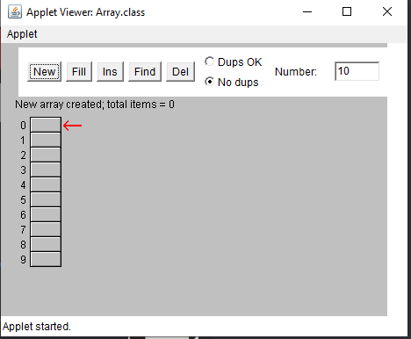 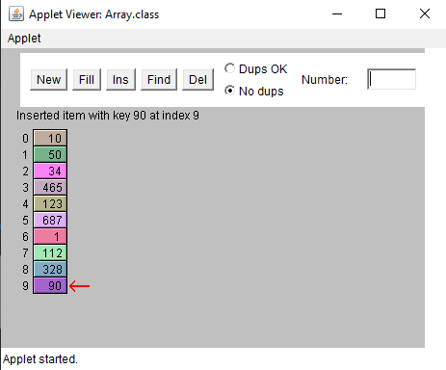 **Inserted 10 cells manually**

**Searching for cell with Number 1**

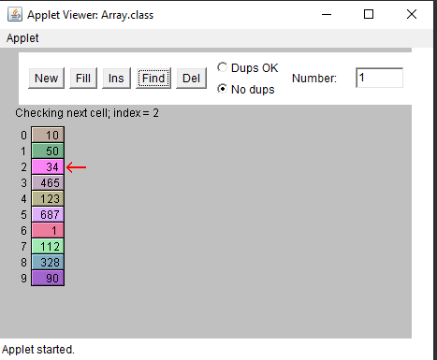

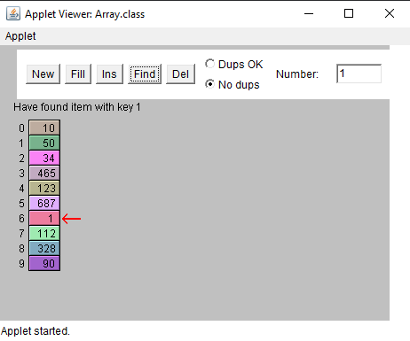 **Have found cell with Number 1**

**Searching to Delete Number 1**

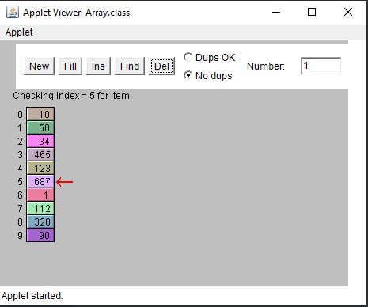**Deleted Number 1**

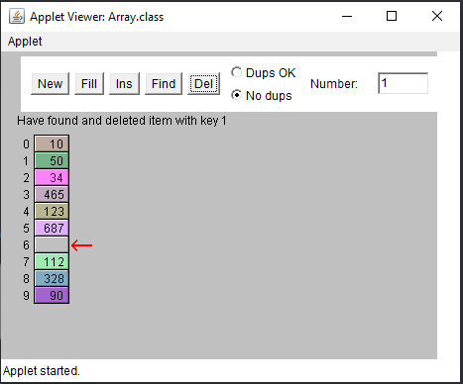

**Shifting Cells are Deletion**

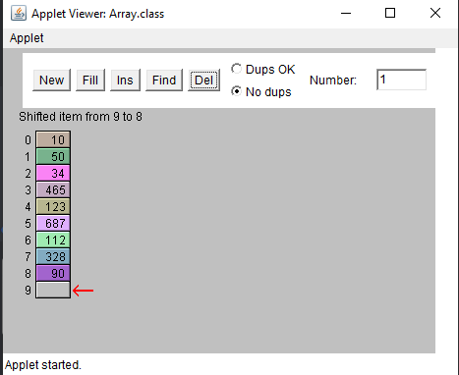

**Results and Analysis**

For a maximum array size of 60 cells, manually clicking one by one to search for the desired cell can become quite tedious for an unordered array. Even if the task of combing through an array cell by cell was assigned to the program to perform, the search speed would be incredibly slow as the array grew larger, into the hundreds or thousands to search for a random number with no significance other than to fill an empty void in an example program. With my limited knowledge, I believe it would be more efficient to order the array with every new entry, and allow the program to attempt a binary search to find the minimum amount of steps required to search for the key search term.

**Conclusion**

In this project, I successfully downloaded Java JDK 1.8.0, edited the windows system variables and opened the java applet using the windows command prompt. From the applet, I followed the instructions given and provided sufficient screenshots of the applets various functions. Once completed, I gave a brief opinion that on a small scale array, the step by step process of searching a small array was too inefficient for a random array, and gave the opinion that the array should be ordered as new data is entered and searching using a binary search method.